**Chapter 13 Statement of Cash Flows**

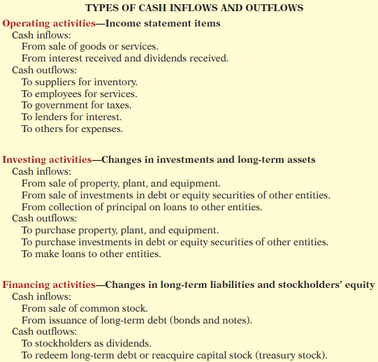

Note the following general guidelines:

**1.** Operating activities involve income statement items.

**2.** Investing activities involve cash fl ows resulting from changes in investments

and long-term asset items.

**3.** Financing activities involve cash fl ows resulting from changes in long-term

liability and stockholders’ equity items.

**Significant Noncash Activities**

**1.** Direct issuance of common stock to purchase assets.

**2.** Conversion of bonds into common stock.

**3.** Direct issuance of debt to purchase assets.

**4.** Exchanges of plant assets.

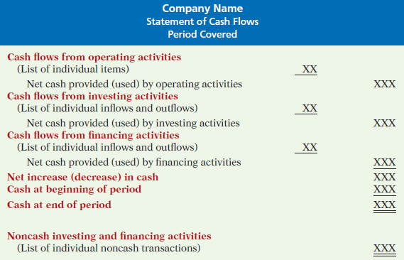 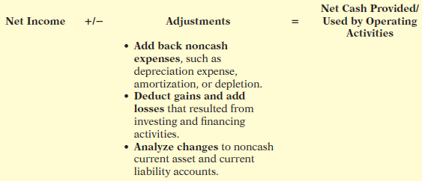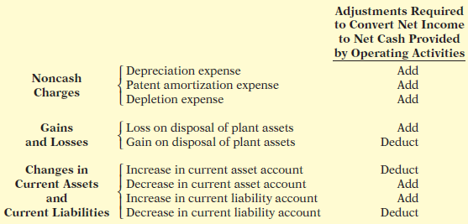

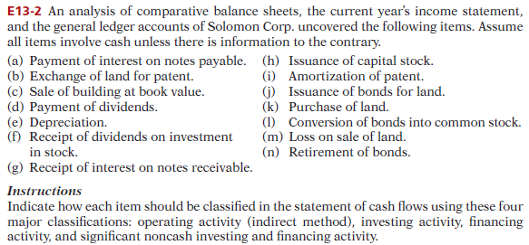

E13-4 Bracewell Company reported net income of $195,000 for 2014. Bracewell also

reported depreciation expense of $40,000 and a gain of $5,000 on disposal of plant assets.

The comparative balance sheet shows an increase in accounts receivable of $15,000

for the year, a $17,000 increase in accounts payable, and a $4,000 decrease in prepaid

expenses.

***Instructions***

Prepare the operating activities section of the statement of cash fl ows for 2014. Use the

indirect method.

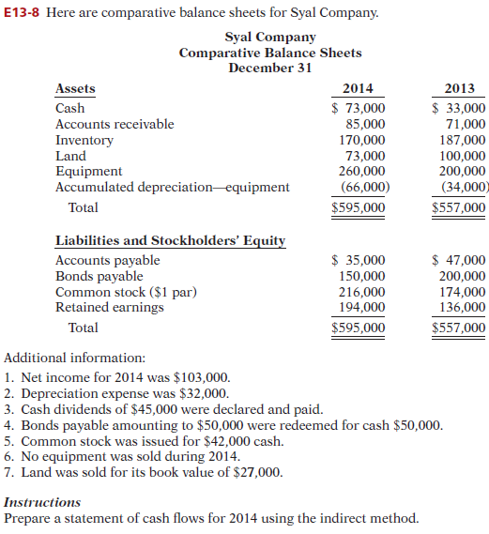

P13-1A You are provided with the following transactions that took place during a recent

fiscal year.

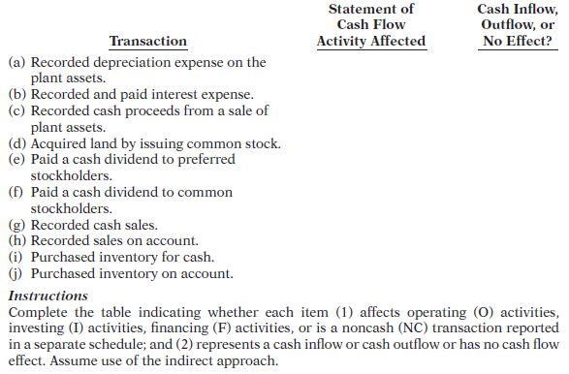

P13-3B The income statement of Asquith Company is presented on the next page.

Additional information:

1. Accounts receivable decreased $230,000 during the year, and inventory increased

$120,000.

2. Prepaid expenses increased $125,000 during the year.

3. Accounts payable to merchandise suppliers increased $50,000 during the year.

4. Accrued expenses payable increased $155,000 during the year.

